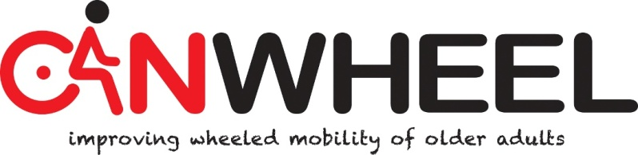

FAST FACTS
Caregiver Assistive Technology Outcomes Measure –Power Wheelchair (CATOM-PW)

Description/Use:
The CATOM is a 18-item outcome measure that was constructed based on a conceptual framework of outcomes for caregivers of assistance users (Demers et al., 2009). It measures the caregiver’s perception of the impacts of AT in his or her life. It may also be used to assess change between assessment and reassessment after an AT-related intervention. The CATOM-PW is an adaptation of the CATOM. The first part of the CATOM-PW version identifies and enumerates all of the care recipient's wheelchair-related activities for which the caregiver provides assistance. It then measures (14 items) elements of burden associated with those wheelchair-related activities. The second part (4 items) captures the caregiver’s perceived burden of all of the assistance they provide and overall quality of life.

Population:
The CATOM was initially developed and used with caregivers of older adults having a physical disability, using a variety of mobility and self-care-related AT. The CATOM-PW was adapted for studies involving caregivers of older PWC users.

Type of Administration:
The CATOM (and CATOM-PW) is administered in a structured interview format. It was developed in Canadian English and Canadian French. It was tested for test-retest reliability with face-to-face data but may also be used over the phone.

Time to Administer:
On average, it takes 13 minutes to administer ± 7 minutes.

Response Scale:
Individual items are rated for frequency of elements of burden.
5 = No
4 = Rarely
3 = Sometimes
4 = Frequently
5 = Nearly always

It there are follow-up assessments, individual items may also be rated for change in frequency with optional questions.
1= A lot more
2 = A little more
3 = The same
4 = A little less
5 = A lot less

Scoring:
Total scores are obtained by summing up frequency responses.
For wheelchair-related help: scores ranging from 14 to 70 (higher score indicating less burden).
For overall help: ranging from 4 to 20 (higher score indicating less burden)
Change scores are described at the individual level, since the psychometric properties for total change scores are not yet available.

Interpretation:
For CATOM-PW, based on the assessments of 27 caregivers of older PWC users, the most common values were 56 ± 8 (wheelchair-related help) and 14 ± 4 (overall help).
Minimal detectable change scores and cut-off scores are not yet available. However, for CATOM, an intervention study showed increased scores from baseline to reassessment, from 51 ± 11 to 61 ± 7 (for activity specific help) and from 14 ± 4 to 15 ± 4 (for overall help).

Relevant References:

- Demers L, Fuhrer MJ, Jutai J, Lenker J, Depa M, De Ruyter F. A conceptual framework of outcomes for caregivers of assistive technology users. Am J Phys Med Rehabil. 2009;88:645-655.
- Mortenson WB, Demers L. (2011). End-user involvement in the development and evaluation of the caregiver assistive technology outcome measure. In G.K. Gelderblom, M.Soede, L. Adriaens, & K. Meisenberger (Eds.) Everyday technology for independence and care (pp. 1043-1050). Fairfax, VA: IOS Press. doi: 10.3233/978-1-60750-814-4-1043. Paper presented at the European Conference for the Advancement of Assistive Technology, Aug., Maastricht, Netherlands.
- Demers L, Mortenson B, & Fuhrer M. (2012). Measuring the impact of assitive technology on family caregivers. In: M.Scherer, S.Federici (Eds), Assistive Technology – A Handbook for Professionals in Disability, Rehabilitation and Health Profession, Chapter 5. NY : Taylor & Francis. pp. 83-100.
- Mortenson B, Demers L, Fuhrer M, Jutai J, Lenker J, DeRuyter F. (2013). Effects of an assistive technology intervention on older adults with disabilities and their informal caregivers. American Journal of Physical Medicine and Rehabilitation, 92, 297-306.
- Mortenson B, Demers L. et al. (submitted June 2014). Development and Preliminary Evaluation of the Caregiver Assistive Technology Outcome Measure. Journal of Rehabilitation Medicine.

